VIDUSH SOMANY INSTITUTE OF

TECHNOLOGY AND RESEARCH, KADI



**KADI SARVA VISHWAVIDYALAYA, GANDHINAGAR**

**CT305-N**

**IT Workshop**

**Ad**

LAB MANUAL

**SEMESTER - 3**

**5**

|  |  |
| --- | --- |
| **ENROLLMENT NO :** |  |
| **NAME :** |  |
| **BRANCH :** |  |

**INDEX**

|  |  |  |  |  |  |
| --- | --- | --- | --- | --- | --- |
| **No** | **Aim** | **Marks** | **Date** | **Sign** | **Remark** |
| **1** | **Design web pages for your college containing a description of the**  **courses, departments, faculties, library etc. Use Href and list tags.** |  |  |  |  |
| **2** | **Create your class timetable using table tag.** |  |  |  |  |
| **3** | **Create user Student feedback form (use textbox, text area, checkbox,**  **radio button, select box etc.)** |  |  |  |  |
| **4** | **Create a web page using frame. Divide the page into two parts with Navigation links on left hand side of page (width=20%) and content page on right hand side of page (width = 80%). On clicking the navigation Links corresponding content must be shown on the right**  **hand side.** |  |  |  |  |
| **5** | **Create your resume using HTML tags also experiment with colors,**  **text, link , size and also other tags you studied.** |  |  |  |  |
| **6** | **Design a web page of your home town with an attractive background**  **color, text color, an Image, font etc. (use internal CSS).** |  |  |  |  |
| **7** | **Use Inline CSS to format your resume that you created.** |  |  |  |  |
| **8** | **Use External CSS to format your class timetable as you created** |  |  |  |  |
| **9** | **Use External, Internal, and Inline CSS to format college web page that**  **you created** |  |  |  |  |
| **10** | **Make any logo and 5 PSD( Design) of Home page of website using**  **Adobe Illustrator or Photoshop applying vectors and scalar , Filters etc** |  |  |  |  |
| **11** | **Develop a JavaScript to display today’s date.** |  |  |  |  |
| **12** | **Develop simple calculator for addition, subtraction, multiplication and**  **division operation using JavaScript** |  |  |  |  |
| **13** | **Create HTML Page with JavaScript which takes Integer number as**  **input and tells whether the number is ODD or EVEN** |  |  |  |  |
| **14** | **Create HTML Page that contains form with fields Name, Email, Mobile No, Gender, Favourite Color and a button. Also write a JavaScript code to combine and display the information in textbox when the button is**  **clicked.** |  |  |  |  |
| **15** | **Write a JavaScript code to rotate images after a specific time interval** |  |  |  |  |
| **16** | **Create an XML file and XML Schema to store student information like**  **Enrolment Number, Name , Mobile Number and Email Id** |  |  |  |  |
| **17** | **Create Document Type Definition (DTD) for above XML File.** |  |  |  |  |
| **18** | **Write a php program to check if number is prime or not.** |  |  |  |  |
| **19** | **Create HTML page that contain textbox, submit / reset button. Write**  **php program to display this information and also store into text file.** |  |  |  |  |
| **20** | **Write a php script to read data from txt file and display it in html table**  **(the file contains info in format Name: Password: Email )** |  |  |  |  |
| **21** | **Write a PHP Script for login authentication. Design an html form which takes username and password from user and validate against stored**  **username and password in file** |  |  |  |  |
| **22** | **Write PHP Script for storing and retrieving user information from MySql table. 1. Design A HTML page which takes Name, Address, Email and Mobile No. From user (register.php) 2. Store this data in Mysql database / text file. 3. Next page display all user in html table**  **using PHP ( display.php )** |  |  |  |  |
| **23** | **Create one blog website using wordpress, using different available plug-in (take free available theme) But, try to implement all the features of blog website** |  |  |  |  |
| **24** | **Implement the basic website structure using Code Ignitor Framework** |  |  |  |  |
| **25** | **Using ajax fetch information from a database with AJAX** |  |  |  |  |
| **26** | **Install Scilab and get familiar with general environment and console** |  |  |  |  |
| **27** | **Get simple Mathematical/Numerical operations executed in scilab** |  |  |  |  |
| **28** | **Plot curves graphs using the graphics window** |  |  |  |  |

**Practical 1:**

**Aim: Design web pages for your college containing a description of the courses, departments, faculties, library etc. Use Href and list tags.**

**Code:**

**<html>**

**<head>**

**<title> VSITR </title>**

**</head>**

**<body>**

**<h1>WELCOME TO VIDUSH SOMANY INSTITUE OF TECHNOLOGY RESEARCH & KADI</h1>**

**<a href="https://vsitr.ac.in/"</a>**

**<ul>**

**<li><h1>courses</h1></li>**

**<ul type="Square">**

**<li>Bachelor of Engineering (BE)</li>**

**</ul>**

**<br/>**

**<li><h1>department</h1></li>**

**<ol type="1">**

**<li>CSE</li>**

**<li>CE</li>**

**<li>IT</li>**

**</ol>**

**<br/>**

**<li><h1>faculties</h1></li>**

**<ol type="1">**

**<li>DR.H.B.PATEL</li>**

**<li>N.S.PATEL</li>**

**<li>J.R.PATEL</li>**

**<li>DR.P.V.S</li>**

**<li>H.M.P</li>**

**</ol>**

**<br/>**

**</body>**

**</html>**

**Output:**

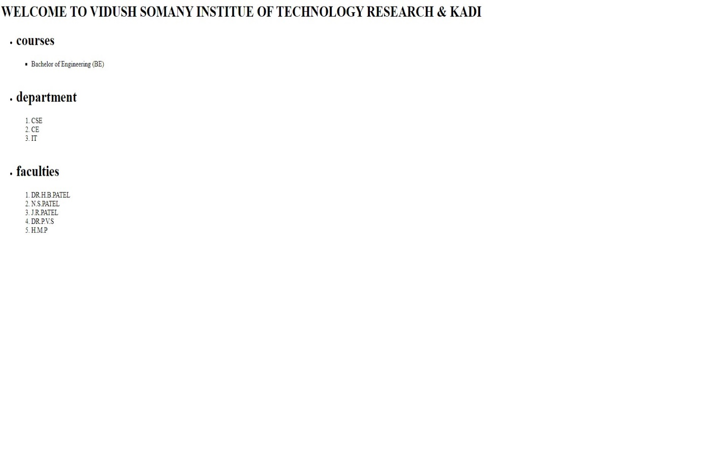

**PRACTICAL 2:**

**Aim: Create your class timetable using table tag.**

**CODE:**

**<html>**

**<head>**

**<title> CLG TIME TABLE</title>**

**</head>**

**<body>**

**<table border =1 height =500 width =500 align="center">**

**<tr>**

**<td colspan ="6" rowspan ="1" align =center><h2> VIDUSH SOMANY INSTITUE OF TECHNOLOGY & RESEARCH, KADI</h2></td>**

**</tr>**

**<tr>**

**<tr><td colspan ="6" rowspan ="1" align =center><h3> semester-III[with effective from : 06/062024] </h3></td>**

**</tr>**

**<tr>**

**<td colspan ="6" rowspan ="1" align =center><h3> CLASS TIME TABLE -Kadi =3K</h3></td>**

**</tr>**

**<tr>**

**<th> TIME</th>**

**<th>MONDAY </th>**

**<th>TUESDAY </th>**

**<th>WEDNESDAY </th>**

**<th>THURSDAY </th>**

**<th>FRIDAY </th>**

**</tr>**

**<tr>**

**<td>9:00 am to 9:50 am</td>**

**<td>DSA(HBP)</td>**

**<td>DM(PD) </td>**

**<td>DBMS(NSP) </td>**

**<td>DBMS(HPM) </td>**

**<td>ITW(PVS) </td>**

**</tr>**

**<tr>**

**<td>9:55 am to 10:45 am</td>**

**<td>DE(JRP)</td>**

**<td>DM(PD) </td>**

**<td > DBMS(NSP)</td>**

**<td>DBMS(HPM) </td>**

**<td>DSA(FC) </td>**

**</tr>**

**<tr>**

**<td align=center colspan ="6"> BREAK</td>**

**</tr>**

**<tr>**

**<td>11:00 am to 11:50 am</td>**

**<td>DSA(HBP)</td>**

**<td>DM(PD) </td>**

**<td>DBMS(NSP) </td>**

**<td>DE(JRP) </td>**

**<td>ITW(PVS) </td>**

**</tr>**

**<tr>**

**<td>11:55 am to 12:45 am</td>**

**<td>DSA(HBP)</td>**

**<td>DM-TUT(PD) </td>**

**<td>DE(JRP) </td>**

**<td>DE(JRP) </td>**

**<td>DBMS(NSP) </td>**

**</tr>**

**<tr> <td align = center colspan ="6"> BREAK </td>**

**<tr>**

**<td>1:20 am to 2:10 am</td>**

**<td>DSA(HBP)</td>**

**<td>ITW(HMP) </td>**

**<td>DE(JRP) </td>**

**<td>DBMS(NSP) </td>**

**<td>ITW(PVS) </td>**

**</tr>**

**<tr>**

**<td>2:10 am to 3:00 am</td>**

**<td>DSA(HBP)</td>**

**<td>ITW(HMP) </td>**

**<td>DE(JRP) </td>**

**<td>DBMS(NSP) </td>**

**<td>ITW(PVS) </td>**

**</tr>**

**</table>**

**</body>**

**</html>**

**OUTPUT:**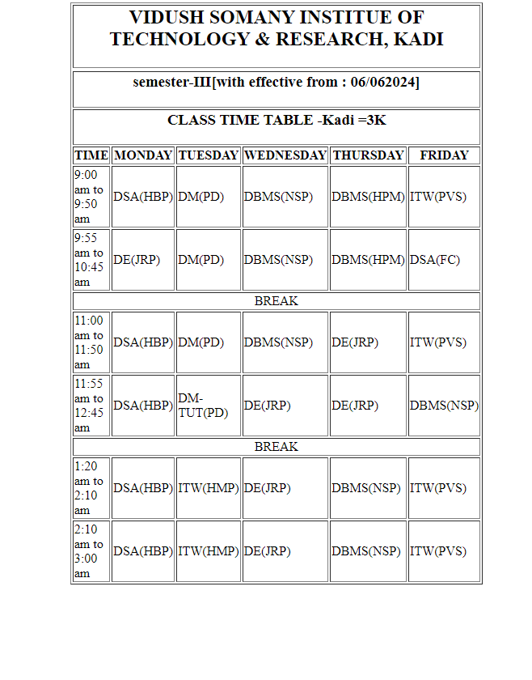

**PRACTICAL 3:**

**Aim: Create user Student feedback form (use textbox, text area, checkbox, radio button, select box etc.)**

**Code:**

**<html>**

**<head>**

**<title>feedback form</title>**

**</head>**

**<body>**

**<h1> <center>STUDENT FEEDBACK</h1>**

**<form>**

**<table border="3" cellspacing="10" align="center">**

**<tr>**

**<td >**

**<label for="fname">**

**<fontcolor="black"><b>First name:</b>**

**</label>**

**<br>**

**<input type="text" placeholder="Enter Firstname" id="fname" name="fname">**

**<br>**

**</td>**

**</tr>**

**<tr>**

**<td>**

**<label for="lname">**

**<fontcolor="black"><b>Last name:</b>**

**</label>**

**<br>**

**<input type="text" placeholder="Enter Lastname" id="lname" name="lname">**

**<br>**

**</td>**

**</tr>**

**<tr>**

**<td>**

**<label for="Enr Number"><font**

**color="black"><b>Enrollment Number:</b>**

**</label>**

**<br>**

**<input type="text" placeholder="EnterEnrollment Number" id="Enr Number" name="Enr Number">**

**<br>**

**</td>**

**</tr>**

**<tr>**

**<td>**

**<label for="Enr Number"><font**

**color="black"><b>Select Your Hobby:</b>**

**</label>**

**<br>**

**<input type="checkbox" name="Reading">**

**<label for="Branch">**

**<fontcolor="black"><b>Reading</b>**

**</label>**

**<input type="checkbox" name="Singing">**

**<label for="Branch">**

**<fontcolor="black"><b>Singing</b>**

**</label>**

**<input type="checkbox" name="Playing">**

**<label for="Branch">**

**<fontcolor="black"><b>Others</b>**

**</label>**

**<br>**

**</td>**

**</tr>**

**<tr>**

**<td>**

**<label for="Email Id">**

**<fontcolor="black"><b>Email Id:</b>**

**</label>**

**<br>**

**<input type="text" placeholder="Enter EmailId" id="Email Id" name="Email Id">**

**<br>**

**</td>**

**</tr>**

**<tr>**

**<td>**

**<label for="Enr Number">**

**<fontcolor="black"><b>Select Your Branch:</b>**

**</label>**

**<br>**

**<input type="radio" id="Branch"name="Branch" value="CE">**

**<label for="CE">**

**<fontcolor="black"><b>CE</b>**

**</label>**

**<br>**

**<input type="radio" id="Branch"name="Branch" value="CSE">**

**<label for="CSE">**

**<fontcolor="black"><b>CSE</b>**

**</label>**

**<br>**

**<input type="radio" id="Branch"**

**name="Branch" value="IT">**

**<label for="Branch">**

**<fontcolor="black"><b>IT</b>**

**</label>**

**<br>**

**</td>**

**</tr>**

**<tr>**

**<td>**

**<label for="feedback">**

**<fontcolor="black"><b>Your Feedback:</b>**

**</label>**

**<br>**

**<textarea id="Feedback" placeholder="Enter**

**your Feedback For This college and Your Faculty " name="feedback" rows="4" cols="50">**

**</textarea>**

**<br>**

**</td>**

**</tr>**

**<tr>**

**<td align="center">**

**<input type="submit" value="Submit">**

**<input type="reset" name="reset">**

**</td>**

**</tr>**

**</table>**

**</form>**

**</body>**

**</html>**

**OUTPUT:**

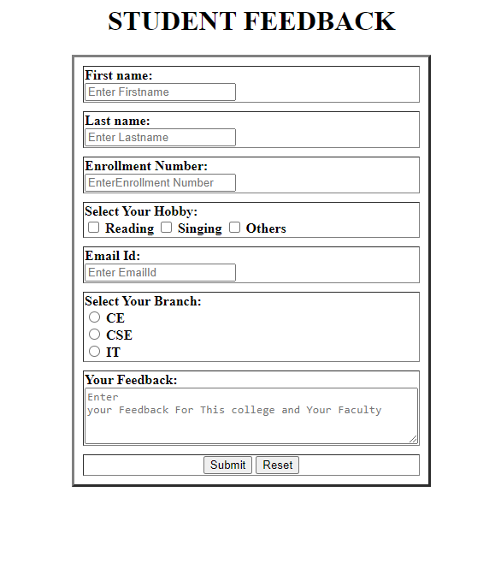

**PRACTICAL 4:**

**AIM: Create a web page using frame. Divide the page into two parts with Navigation links on left hand side of page (width=20%) and content page on right hand side of page (width = 80%). On clicking the navigation Links corresponding content must be shown on the right hand side**

**CODE:**

**!navbar :**

**<html>**

**<head>**

**<title>Student Feedback Form</title>**

**<style>**

**body {**

**font-family: Arial, sans-serif;**

**display:flex;**

**align-items:center;**

**justify-content:center;**

**height:100vh;**

**}**

**</style>**

**</head>**

**<body>**

**<nav style="display:flex; flex-direction:column; gap:20px;">**

**<a href="../practical2.html" target="right">Practical 2 </a>**

**<a href="../practical3.html" target="right">Practical 3 </a>**

**<a href="../practical1.html" target="right">Practical 1 </a>**

**</nav>**

**</body>**

**</html>**

**!Mainfile :**

**<html>**

**<head>**

**<title>Student Feedback Form</title>**

**<style>**

**body {**

**font-family: Arial, sans-serif;**

**color:black;**

**width:100%;**

**height:100%;**

**}**

**</style>**

**</head>**

**<frameset cols="20%, 80%">**

**<frame name="left" src="frames/navbar.html" />**

**<frame name="right" />**

**</frameset>**

**</html>**

**OUTPUT:**

**––**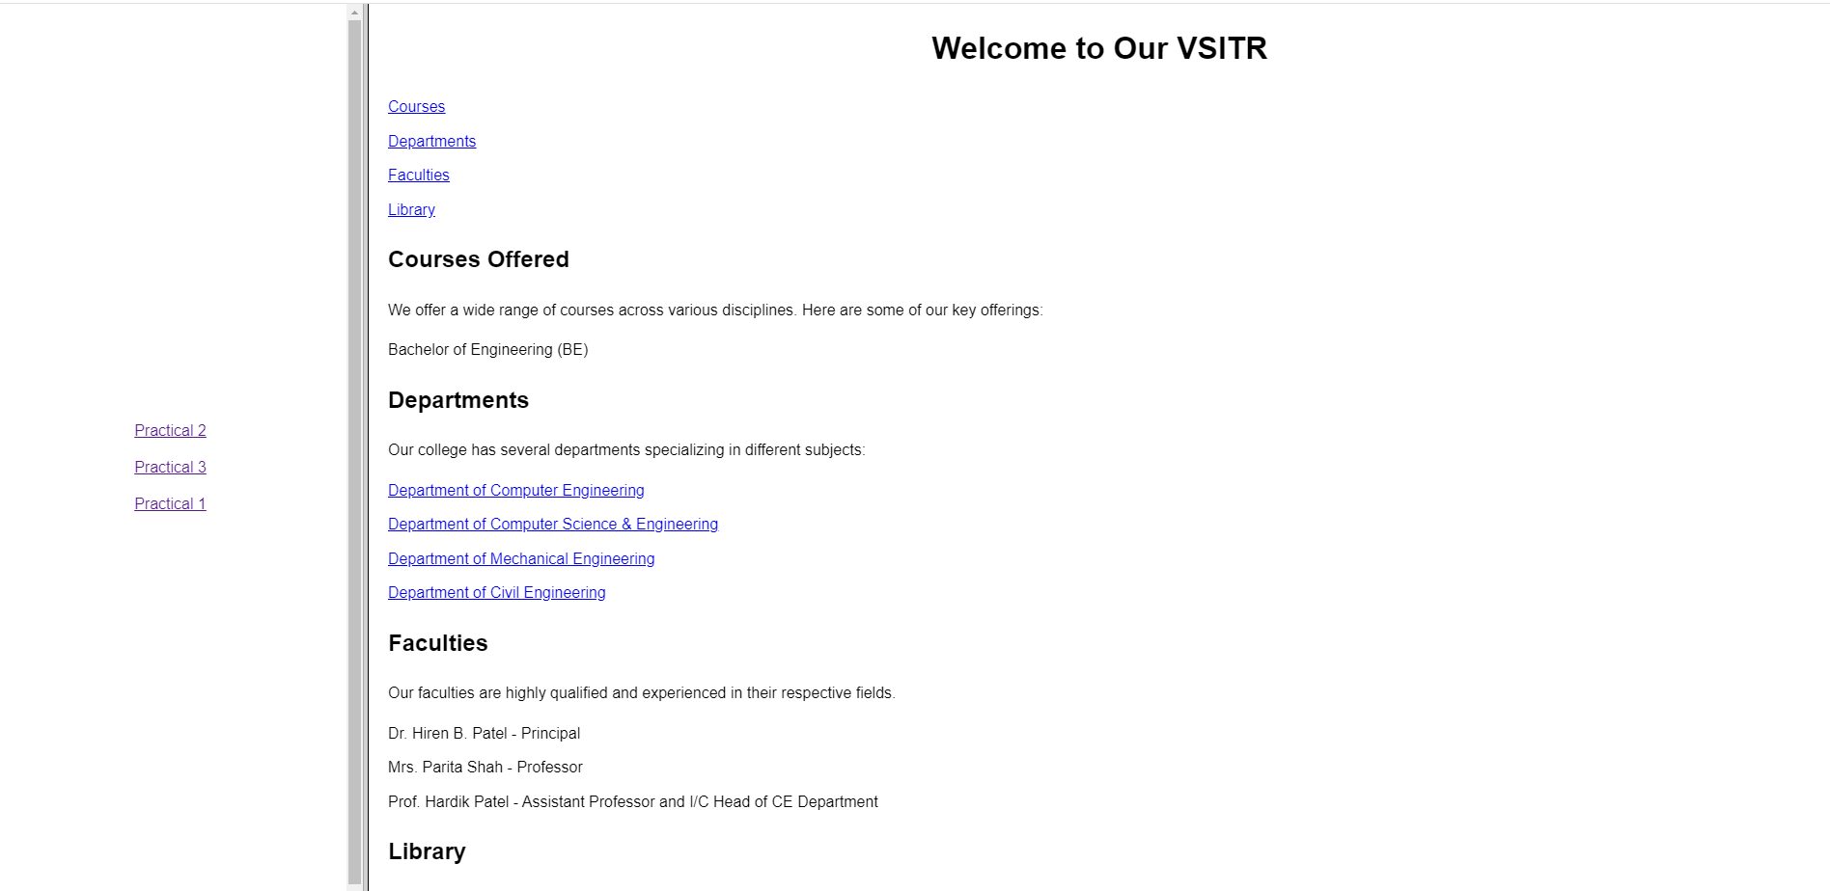

**PRACTICAL 5:**

**AIM: Create your resume using HTML tags also experiment with colors, text, link , size and also other tags you studied**

**CODE:**

**<html>**

**<head>**

**<title>resume</title>**

**<style>**

**body{**

**font-family: 'Caveat', cursive;**

**background: linear-gradient(to bottom right, #F76D57, #6438A4);**

**color: white;**

**}**

**h1,h2,li,dt{**

**margin-left: 80px;**

**}**

**</style>**

**</head>**

**<body>**

**<h1><center>Margi Patel</h1>**

**<imgsrc="D:\SEM3\ITW\html\ganpatidada.jpg" style="width:100px;height:100px;" alt="picture">**

**<br>**

**<p>**

**<h2><u>Education:</u></h2>**

**<ul>**

**<li>Sarva vidhyalaya high school</li>**

**<li>Vidush Somany Institute of Technology & Research</li>**

**</ul>**

**</p>**

**<br>**

**<p>**

**<h2><u>Interest:</u></h2>**

**<ul>**

**<li>Travelling</li>**

**<li>Music</li>**

**<li>Playing</li>**

**<br>**

**</ul>**

**</p>**

**<p>**

**<h2><u>Skill:</u></h2>**

**<ul>**

**<li>HTML</li>**

**<li>CSS</li>**

**<li>Good speaker</li><br>**

**</ul>**

**</p>**

**<p>**

**<h2><u>Experience:</u></h2>**

**<dl>**

**<dt><b>Company 1</b>**

**</dt>**

**<dd>Worked as web developer.</dd>**

**</dl>**

**<dl>**

**<dt><b>Company 2</b></dt>**

**<dd>Worked as web developer.</dd>**

**</dl>**

**<dl>**

**<dt><b>Company 3</b></dt>**

**<dd>Worked as web developer.</dd><br>**

**</dl>**

**</p>**

**<p>**

**<ul>**

**<h2><u>Contact Info:</u></h2>**

**<li><b>E-mail:</b> margipatel.2303@gmail.com**

**</li>**

**<li> <b>Phone No.:</b>992*******</li>**

**</ul>**

**</p>**

**</body>**

**</html>**

**OUTPUT:**

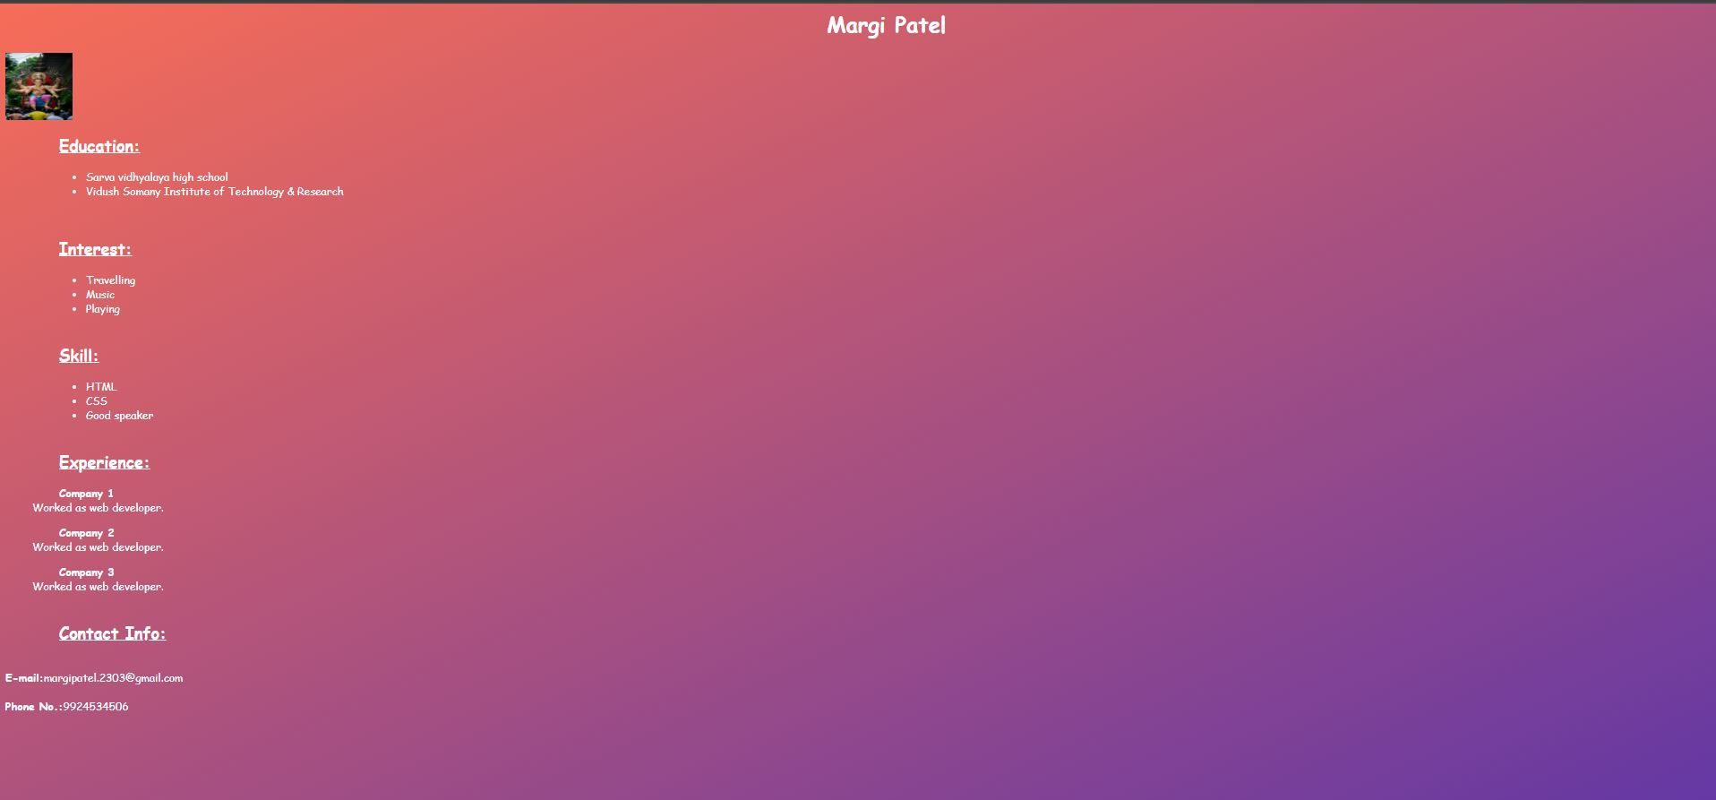

**PRACTICAL 6:**

**AIM: Design a web page of your home town with an attractive background color, text color, an Image, font etc. (use internal CSS)**

**CODE:**

**<html>**

**<head>**

**<title>Home Town</title>**

**</head>**

**<style>**

**body**

**{**

**margin: 0;**

**padding: 0;**

**font-family: 'Caveat', cursive;**

**background: linear-gradient(to bottom right, #F76D57, #6438A4);**

**color: white;**

**}**

**header**

**{**

**text-align: center;**

**padding: 20px ;**

**}**

**p,h3,ul,li**

**{**

**margin-left: 80px;**

**}**

**</style>**

**<body>**

**<div class="tiledBackground">**

**</div>**

**<center><h1> Kadi </h1>**

**<p>#Golden city </p>**

**<imgsrc="D:\SEM3\ITW\html\MAHADEV.jpg"/ style="width:100px;height:100px;" alt="picture">**

**</center>**

**<br/>**

**<br/>**

**<p>**

**Total Numbers of Villages : 120**

**</br>**

**</br>**

**Crops : Sorghum, Cotton, Wheat, Mustard Seeds, Cumin Seeds etc.**

**</br>**

**</br>**

**Domestic Animals : Cows, buffaloes, camels, donkeys, goats etc.**

**</br>**

**</br>**

**Minerals : Oil & Natural Gas**

**</br>**

**</br>**

**Industries : Cotton processing, Cotton seed processing, Cotton oil Refineries, Ceramic industry and many more.**

**</br>**

**</br>**

**Tourist Points: Meladi mata temple, Malhavrav Fort, Umiya mata temple, Narmada Canal diversion, Municipal Garden, Malji Bhagat ni Vav, Oghadnath Mahadev temple, Dasiya pir dargah, maneksha bawa dargah, Balapir bava ki dargah, Thol Lake is there which is 22 km away from kadi, known as a bird sanctuary Thol Lake. Many out of countries birds used to come in winter at thol lake**

**</br>**

**</br>**

**Schools : Bhavkunj School, Noble School Vidhya Mandir Primary and Higher Secondary School, Sheth R.H.High school & R.C.Patel higher secondary school, Merda-Adraj, Sarva Vidhyalaya Kelavani Mandal, Adarsh Vidhyalay, Zaveri High School, Little Angels School.**

**</br>**

**</br>**

**Hospital : Bhagyoday Hospital, Devansh icu and medical hospital, Block Health Office, Sneh Children Hospital And Nicu, Rhythm Medical And Heart Hospital, Maruti Hospital And Test Tube Baby Centre, Krishna Hospital.**

**</br>**

**</br>**

**Green vegetable market : In kadi there is a wide green vegetable market and starts trading by early morning and mostly stops before noon, almost green vegetable seller come from nearer villages and sell in bulk qty with lower price. Lemon (LIMBU) is available here in large qty at lower price, because around villages have too much plants for lemon.**

**</br>**

**</br>**

**Middle class business center : This city is very popular for shopping cloths as well as jewelry (Ornaments) while any festival or wedding time arrived.**

**</p>**

**<h3>Famous Things in Kadi</h3>**

**<ul class="button">**

**<li><a href="p.html"><button class="button"> Meldi mata temple </button></a></li>**

**<li><a href="t.html"><button class="button"> Yavteshwar Mahadev Temple</button></a></li>**

**<li><a href="s.html"><button class="button"> Sardarbag </button></a></li>**

**<li><a href="g.html"><button class="button"> Umiya mata temple </button></a></li>**

**<li><a href="s.html"><button class="button"> Narmada Canal diversion </button></a></li>**

**<li><a href="s.html"><button class="button"> Malji Bhagat ni Vav </button></a></li>**

**<li><a href="s.html"><button class="button"> Oghadnath Mahadev temple </button></a></li>**

**</ul>**

**</body>**

**</html>**

**OUTPUT:**

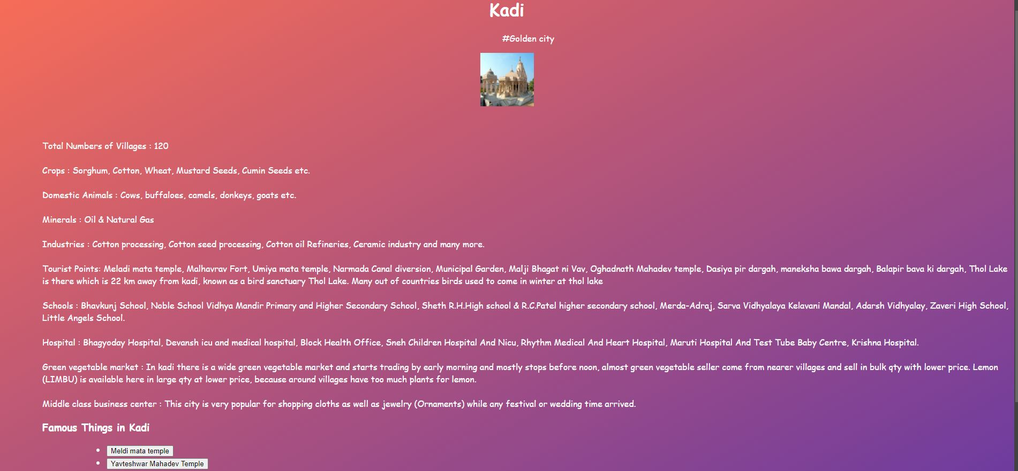

**PRACTICAL 7:**

**Aim: Use Inline CSS to format your resume that you created.**

**Code:**

**Prac-7**

**Use Inline CSS to format your resume that you created.**

**<html>**

**<head>**

**<title>20BECSE54008</title>**

**</head>**

**<body bgcolor="#AED6F1">**

**<H1> <FONTCOLOR="black"><CENTER> <u> <b> RESUME </u> </b> </H>**

**<table border="3" cellspacing="10" align="center">**

**<tr style="background-color:red">**

**<td >**

**<font color="pink"><b><h1>MARGI PATEL</h1></b>**

**<font color="black"><b><h2>Email: margi1000@gmail.com</h2></b>**

**</td>**

**</tr>**

**<tr>**

**<td>**

**<font color="black"><h1><u><b>Interests:</b></u></h1>**

**<ul>**

**<font color="yellow"><h2><b><li>Cricket</li></h2></b>**

**<font color="brown"><h2><b><li>Photography</li></h2></b>**

**<font color="grey"><h2><b><li>Design</li></h2></b>**

**<font color="purple"><h2><b><li>Programming</li></h2></b>**

**<font color="black"><h2><b><li>ComputerScience</li></h2></b> </ul>**

**</td>**

**</tr>**

**<tr>**

**<td>**

**<font color="black"><h1><b><u>Skills</b></u></b></h1>**

**<ul>**

**<font color="black"><h2><b><li>Web Design with HTML & CSS</li></b></h2>**

**</ul>**

**<ul>**

**<font color="black"><h2><b><li>COMPETETIVECODING</li></b></h2>**

**</ul>**

**</td>**

**</tr>**

**<tr style="background-color:green">**

**<td>**

**<font color="black"><h1><u><b>Education</b></u></h1>**

**<ul>**

**<font color="black"><h2><b>**

**<a href="https://www.adanividyamandir.org/">**

**<font color="black"><li>Adani Vidya Mandir</li>**

**</a></b></h2>**

**<font color="black"><h2><b><a href="http://www.vsitr.ac.in/">**

**<font color="black"><li>VIDUSH SOMANY INSTITUTE OF TECHNOLOGY AND RESEARCH</li>**

**</a></h2></b>**

**</td>**

**</tr>**

**</table>**

**</body>**

**</html>**

**Output:**

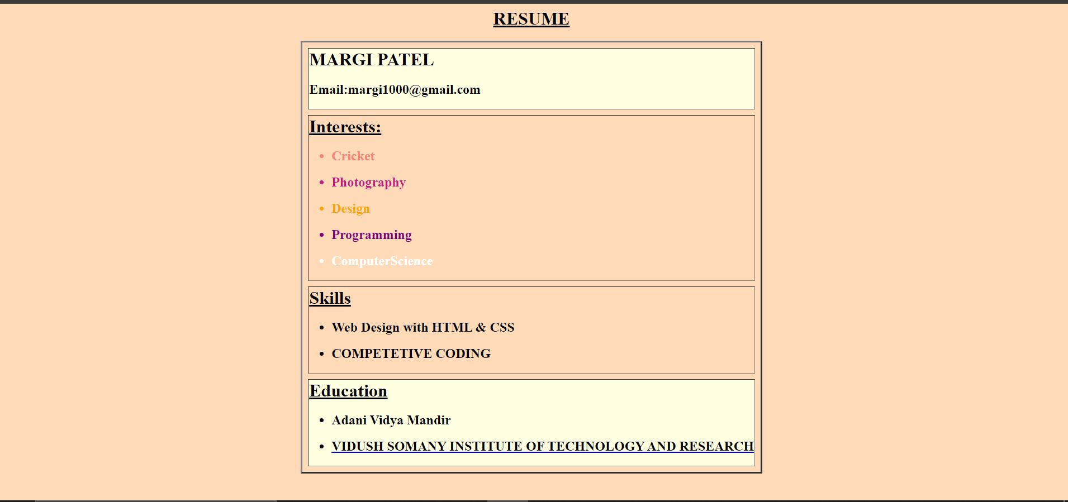

**Practical 8:**

**Aim: Use External CSS to format your class timetable as you created.**

**Code:**

**<!DOCTYPE html>**

**<html lang="en">**

**<head>**

**<meta charset="UTF-8">**

**<meta name="viewport" content="width=device-width, initial-scale=1.0">**

**<title>timetable</title>**

**<style>**

**.table{**

**margin: auto;**

**margin-top: 10%;**

**border: 4px solid black;**

**background-color: #d9e4e7;**

**width: 80%;**

**text-align: CENTER;**

**}**

**.cont{**

**text-align: center;**

**}**

**table,th,td{**

**border: 2px inset black;**

**border-collapse: collapse;**

**}**

**</style>**

**</head>**

**<body>**

**<table class="table">**

**<tr>**

**<th colspan="6">VIDUSH SOMANY INSTITUTE OF RESEARCH & TECHNOLOGY</th>**

**</tr>**

**<tr>**

**<th colspan="6">SEMESTER-3</th>**

**</tr>**

**<tr>**

**<th colspan="6">CLASS TIMETABLE KADI -3K</th>**

**</tr>**

**<tr>**

**<th>TIME</th>**

**<th>MONDAY</th>**

**<th>TUESDAY</th>**

**<th>WEDNESDAY</th>**

**<th>THURSDAY</th>**

**<th>FRIDAY</th>**

**</tr>**

**<tr>**

**<td>9:00 AM TO 9:50 AM</td>**

**<td>ITW (HMP)</td>**

**<td>DM(NVP)</td>**

**<td>DBMS(NSP)</td>**

**<td>DE(JRP)</td>**

**<td>DE(JRP)</td>**

**</tr>**

**<tr>**

**<td>9:55 AM TO 10:45 AM</td>**

**<td>DE(JRP)</td>**

**<td>DBMS(NSP)</td>**

**<td>DM-TUT (NVP)</td>**

**<td>DSA (APM)</td>**

**<td>DBMS(NSP)</td>**

**</tr>**

**<tr>**

**<TD colspan="6">BREAK</TD>**

**</tr>**

**<tr>**

**<TD>11:00 AM TO 11:50 AM</TD>**

**<TD>DM(NVP)</TD>**

**<TD>ITW (HMP)</TD>**

**<TD>DBMS(NSP)</TD>**

**<TD>DE(JRP)</TD>**

**<TD>ITW (HMP)</TD>**

**</tr>**

**<tr>**

**<TD>11:55 AM TO 12:45 PM</TD>**

**<TD>DSA (APM)</TD>**

**<TD>DM(NVP)</TD>**

**<TD>DSA (APM)</TD>**

**<TD>DSA (APM)</TD>**

**<TD>ITW (HMP)</TD>**

**</tr>**

**<tr>**

**<TD colspan="6">BREAK</TD>**

**</tr>**

**<tr>**

**<TD>1:20 PM TO 2:10 PM</TD>**

**<TD rowspan="2">ITW (HMP)</TD>**

**<TD rowspan="2">DBMS(NSP)</TD>**

**<TD rowspan="2">DBMS(NSP)</TD>**

**<TD rowspan="2">DE(JRP)</TD>**

**<TD rowspan="2">DSA (APM)</TD>**

**</tr>**

**<tr>**

**<TD>2:10 PM TO 3:00 PM</TD>**

**<!-- <TD>ITW (HMP)</TD>**

**<TD>DBMS(NSP)</TD>**

**<TD>DBMS(NSP)</TD>**

**<TD>DE(JRP)</TD>**

**<TD>DSA (APM)</TD> -->**

**</tr>**

**</table>**

**</body>**

**</html>**

**OUTPUT:**

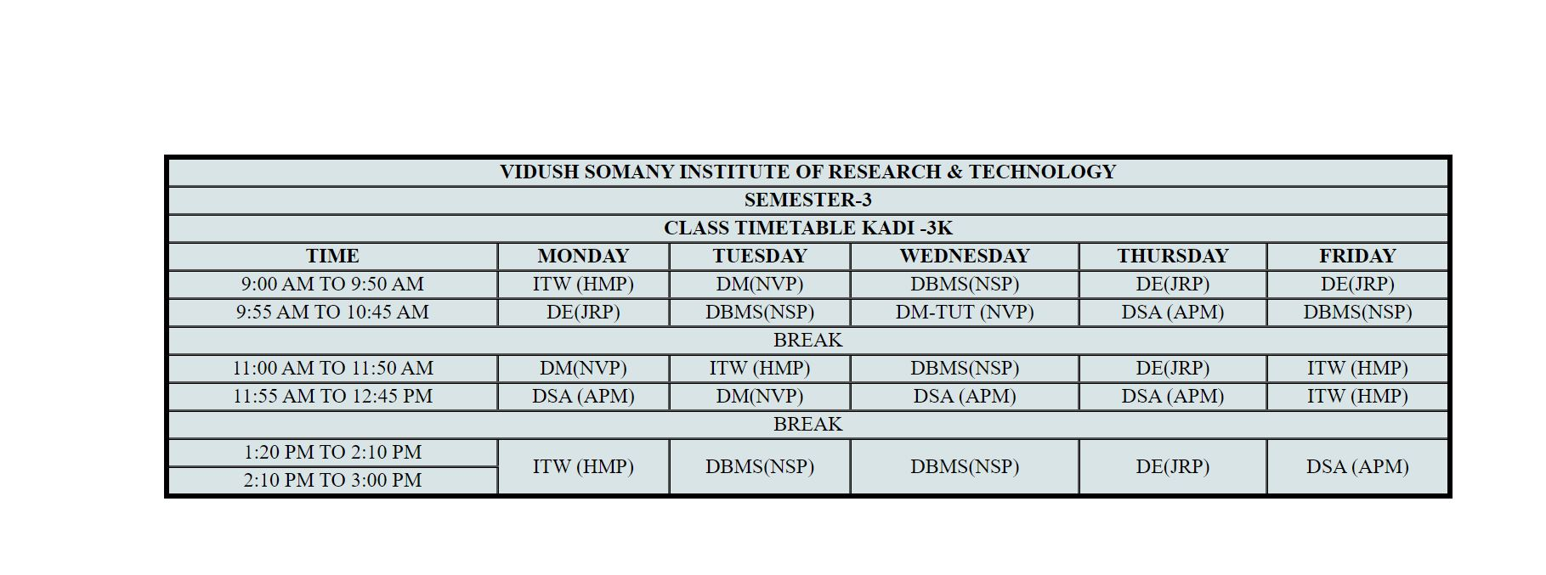

**PRACTICAL 9:**

**AIM: Use External, Internal, and Inline CSS to format college web page that you created.**

**CODE:**

**<!DOCTYPE html>**

**<html lang="en">**

**<head>**

**<meta charset="UTF-8">**

**<meta name="viewport" content="width=device-width, initial-scale=1.0"> <title>Navigation bar</title>**

**<style>**

**body {**

**margin: 0; padding: 0;**

**font-family: Arial, sans-serif;**

**}**

**.navbar {**

**display: flex;**

**width: 100%;**

**height: 100vh;**

**background-color: lightgray;**

**}**

**.nav-item {**

**flex: 1;**

**padding: 10px;**

**text-align: center;**

**color: black;**

**font-weight: bolder;**

**cursor: pointer;**

**transition: background-color 0.3s ease;**

**display: flex;**

**flex-direction: column;**

**justify-content: center;**

**align-items: center;**

**}**

**.nav-item img {**

**max-width: 100%;**

**max-height: 100%;**

**/* display: block; */**

**}**

**</style>**

**</head>**

**<body>**

**<div class="navbar">**

**<div class="nav-item">**

**<img src="ksvlogo.png" alt="Image 1"> <p>ksv logo</p>**

**</div>**

**<div class="nav-item">**

**<img src="logo.png" alt="Image 2"> <p>Vsitr logo</p>**

**</div>**

**<div class="nav-item">**

**<img src="vsitr.jpg" alt="Image 3"> <p> Vsitr</p>**

**</div>**

**<div class="nav-item">**

**<img src="2.jpg" alt="Image 4"> <p> mehsana </p>**

**</div>**

**<div class="nav-item">**

**<img src="city1.jpg" alt="Image 4"> <p> mehsana </p>**

**</div>**

**</div>**

**</body>**

**</html>**

**OUTPUT:**

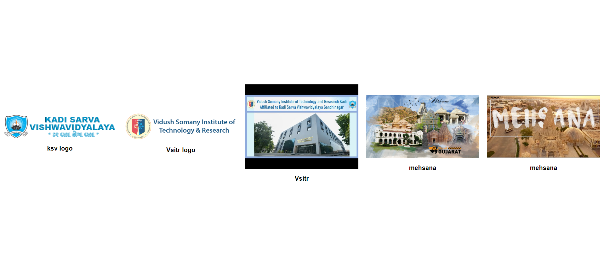

**PRACTICAL 10:**

**AIM: Create HTML Page with JavaScript which takes Integer number as input and tells whether the number is ODD or EVEN**

**<!DOCTYPE html>**

**<html>**

**<head>**

**<title>Odd or Even Checker</title>**

**</head>**

**<body>**

**<h1>Odd or Even Checker</h1>**

**<label for="numberInput">Enter an Integer:</label>**

**<input type="number" id="numberInput" />**

**<button onclick="checkOddOrEven()">Check</button>**

**<p id="result"></p>**

**<script>**

**function checkOddOrEven() {**

**// Get the input value as a number**

**const number = parseInt(document.getElementById("numberInput").value);**

**// Check if the input is a valid number**

**if (!isNaN(number)) {**

**if (number % 2 === 0) {**

**// It's even**

**document.getElementById("result").textContent = number + " is EVEN.";**

**} else {**

**// It's odd**

**document.getElementById("result").textContent = number + " is ODD.";**

**}**

**} else {**

**// Invalid input**

**document.getElementById("result").textContent = "Please enter a valid integer.";**

**}**

**}**

**</script>**

**</body>**

**</html>**

**OUTPUT:**

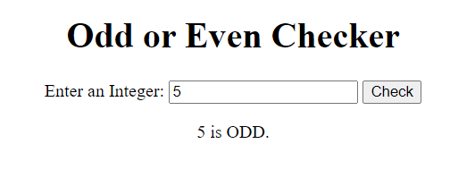

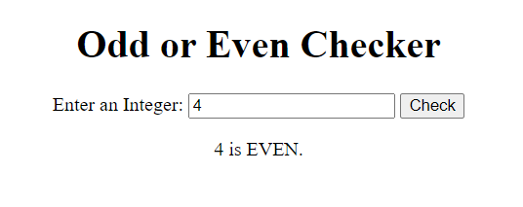

**PRACTICAL 11:**

**AIM: Create HTML Page that contains form with fields Name, Email, Mobile No, Gender, Favourite Color and a button. Also write a JavaScript code to combine and display the information in textbox when the button is clicked.**

**CODE:**

**<html>**

**<head>**

**<title>22BECSE54008 </title>**

**<style>**

**body,table**

**{**

**text-align: center;**

**}**

**</style>**

**<script language="JavaScript">**

**function showInput()**

**{**

**document.getElementById('display').innerHTML = document.getElementById("user_name").value;**

**document.getElementById('display1').innerHTML = document.getElementById("user_email").value;**

**document.getElementById('display2').innerHTML = document.getElementById("user_password").value;**

**document.getElementById('display3').innerHTML = document.getElementById("user_mobile").value;**

**document.getElementById('display4').innerHTML =**

**document.querySelector('input[name="user_gender"]:checked').value;**

**document.getElementById('display5').innerHTML = document.getElementById("user_color").value;**

**}**

**</script>**

**</head>**

**<body>**

**<table>**

**<tr>**

**<td>**

**<h2> REGISTRATION FORM </h2>**

**<form>**

**<b>NAME : <input type="text" id="user_name"></br></br>**

**EMAIL : <input type="email" id="user_email"></br></br>**

**PASSWORD : <input type="password" id="user_password"></br></br>**

**MOBILE NO : <input type="text" id="user_mobile"></br></br>**

**GENDER : <input type="radio" name="user_gender" id="user_gender" value="male" /> male**

**<input type="radio" name="user_gender" id="user_gender" value="female" /> female</br></br>**

**FAVOURITE COLOUR : <input type="text" id="user_color"></br></br></b>**

**</form>**

**<input type="submit" onclick="showInput();"><br />**

**<label>Your input is:</label>**

**<p><span id='display'></span></p>**

**<p><span id='display1'></span></p>**

**<p><span id='display2'></span></p>**

**<p><span id='display3'></span></p>**

**<p><span id='display4'></span></p>**

**<p><span id='display5'></span></p>**

**</td>**

**</tr>**

**</table>**

**</body>**

**</html>**

**OUTPUT:**

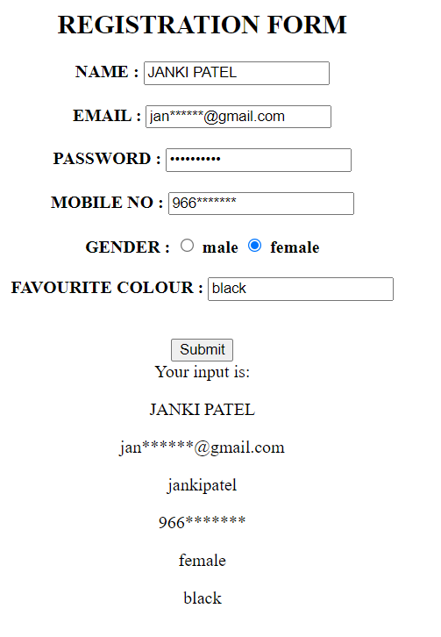

**PRACTICAL 12:**

**AIM: Write a JavaScript code to rotate images after a specific time interval.**

**CODE:**

**<!DOCTYPE html>**

**<html lang="en">**

**<head>**

**<meta charset="UTF-8">**

**<meta name="viewport" content="width=device-width, initial-scale=1.0">**

**<title>Image Rotation</title>**

**<style>**

**#image {**

**transition: transform 1s ease;**

**height: 48%;**

**width: 48%;**

**margin-top: 9%;**

**margin-left: 25%;**

**/* border-radius: 100%; */**

**}**

**</style>**

**</head>**

**<body>**

**<img id="image" src="2.jpg" alt="Image">**

**<script>**

**const image = document.getElementById('image');**

**let rotationAngle = 0;**

**function rotateImage() {**

**rotationAngle += 45; // Rotate by 45 degrees (you can change this value)**

**image.style.transform = `rotate(${rotationAngle}deg)`;**

**}**

**setInterval(rotateImage, 2000); // Rotate every 2 seconds (you can change this interval)**

**</script>**

**</body>**

**</html>**

**OUTPUT:**



**PRACTICAL 13:**

**AIM: Create an XML file and XML Schema to store student information like Enrolment Number, Name, Mobile Number and Email Id.**

**CODE:**

**<?xml version="1.0" encoding="UTF-8"?>**

**<?xml-stylesheet type='text/xsl' href='cgpa.xsl"?>**

**<class>**

**<student>**

**<name> ABC </name>**

**<id> 001 </id>**

**<branch> IT </branch>**

**<cgpa>9</cgpa>**

**</student>**

**<student>**

**<name> PQR </name>**

**<id>004 </id>**

**<branch> Computer </branch>**

**<cgpa> 7 </cgpa>**

**</student>**

**<student>**

**<name> XYZ </name>**

**<id>006 </id>**

**<branch> IT </branch>**

**<cgpa> 10</cgpa>**

**</student>**

**</class>**

**OUTPUT:**

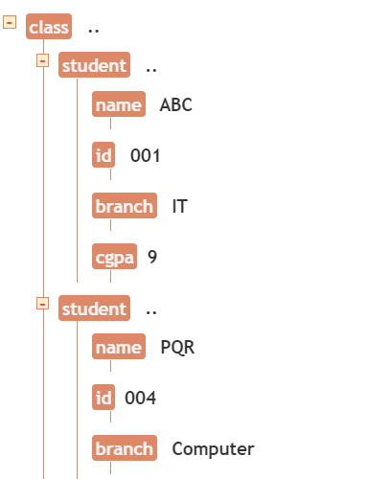

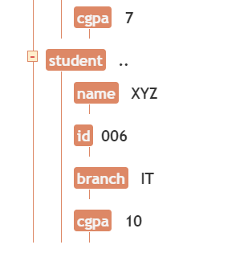

**PRACTICAL 14:**

**AIM: Create Document Type Definition (DTD) for above XML File.**

**CODE:**

**<?xml version="1.0" encoding="UTF-8"?>**

**<xsl:stylesheet version="1.0" xmlns:xsl="https://www.w3.org/1999/XSL/Transform"> <xsl:template match="/">**

**<html>**

**<body>**

**<h2>Student list in descending order of their CGPA.</h2>**

**<table border="1">**

**<tr bgcolor="lightblue">**

**<th>ID</th>**

**<th>Name</th>**

**<th>Branch</th>**

**<th>CGPA</th>**

**</tr>**

**<xsl:for-each select="class/student">**

**<xsl:sort select="cgpa" order="descending" data-type="number"/>**

**<tr>**

**<td><xsl:value-of select="id"/></td>**

**<td><xsl:value-of select="name"/></td>**

**<td><xsl:value-of select="branch"/></td> <td><xsl:value-of select="cgpa"/></td>**

**</tr>**

**</xsl:for-each>**

**</table>**

**</body>**

**</html>**

**</xsl:template>**

**</xsl:stylesheet>**

**OUTPUT:**

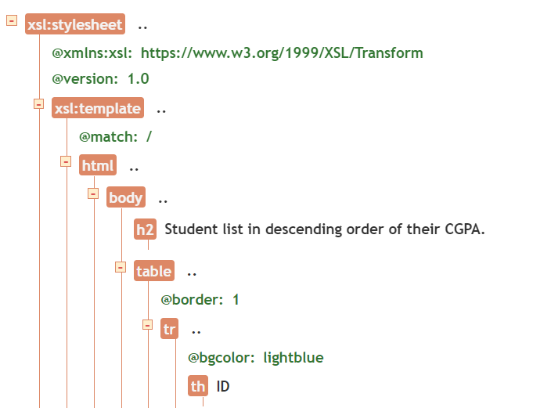

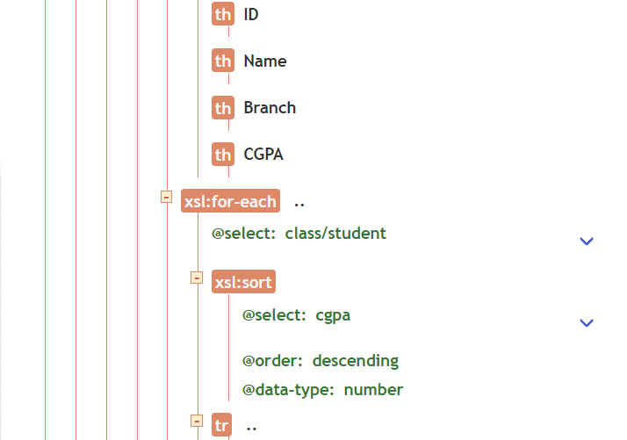

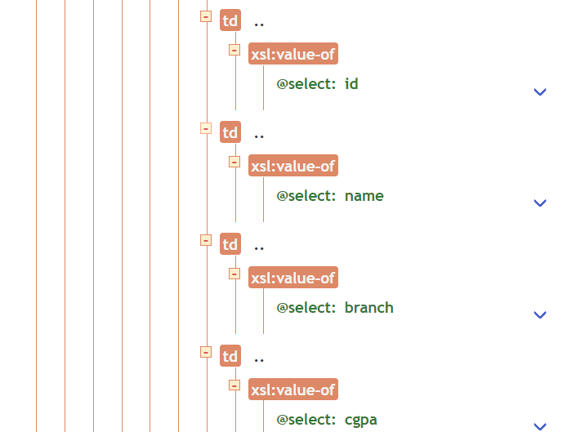

**PRACTICAL 15:**

**AIM: Write a php program to check if number is prime or not.**

**CODE:**

**<html>**

**<head>**

**<title>PHP Test</title>**

**</head>**

**<body>**

**<?php**

**function isPrime($number) {**

**if ($number < 2) {**

**return false;**

**}**

**for ($i = 2; $i * $i <= $number; $i++) {**

**if ($number % $i == 0) {**

**return false; // Check for divisibility by numbers from 2 to the square of the number**

**}**

**}**

**return true;**

**}**

**$number = 17; // Change this to the number you want to check**

**if (isPrime($number)) {**

**echo $number . " is a prime number.";**

**} else {**

**echo $number . " is not a prime number.";**

**}**

**?>**

**<script src="https://replit.com/public/js/replit-badge-v2.js" theme="dark" position="bottom-right"></script>**

**</body>**

**</html>**

**OUTPUT:**

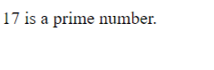

**PRACTICAL 16:**

**AIM: Create HTML page that contain textbox, submit / reset button. Write php program to display this information and also store into text file.**

**CODE:**

**<!DOCTYPE html>**

**<html>**

**<head>**

**<title>Form Example</title>**

**</head>**

**<body>**

**<h1>Simple Form</h1>**

**<form action="process.php" method="post">**

**<label for="name">Name:</label>**

**<input type="text" id="name" name="name" required><br><br>**

**<input type="submit" value="Submit">**

**<input type="reset" value="Reset">**

**</form>**

**</body>**

**</html>**

**<?php**

**if ($_SERVER["REQUEST_METHOD"] == "POST") {**

**$name = $_POST["name"];**

**}**

**// Open a text file for writing (you can specify the path) $file = fopen("data.txt", "a"); // "a" means append to the file**

**if ($file) {**

**fwrite($file, "Name: $name\n"); // Write the data to the file**

**// Close the file**

**fclose($file);**

**// Display a success message**

**echo "Data has been successfully stored in 'data.txt'."; } else {**

**}**

**// Display an error message if the file couldn't be opened echo "Error: Unable to open the file for writing.";**

**?>**

**OUTPUT:**

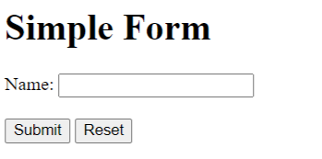

**PRACTICAL 17:**

**AIM: Create an XML file and XML Schema to store student information like Enrolment Number, Name , Mobile Number and Email Id.**

**Code:**

**<?xml version ="1.0"?>**

**<xsl:stylesheet version = "1.0"**

**xmlns:xsl="http://www.w3.org/1999/XSL/Transform"**

**xmlns="http://www.w3.org/TR/xhtml1/strict">**

**<xsl:template match = "/">**

**<h2><font aling="center" size=20px face=cooper> Student**

**Information </font></h2>**

**<xsl:for-each select="students/student">**

**<br/>**

**<span style="font-weight:bold;color:black;font-family:cooper">**

**Name: </span>**

**<xsl:value-ofselect="name" /><br/><br/>**

**<span style="font-weight:bold;color:black;font-family:cooper">**

**Enrollment no: </span>**

**<xsl:value-ofselect="enrollment number" /> <br/><br/>**

**<span style="font-weight:bold;color:black;font-family:cooper">**

**Mobile no: </span>**

**<xsl:value-ofselect="mobile number" /> <br/><br/>**

**<span style="font-weight:bold;color:black;font-family:cooper">**

**Email Id: </span>**

**<xsl:value-ofselect="email id" /> <br/><br/>**

**</xsl:for-each>**

**</xsl:template>**

**</xsl:stylesheet>**

**Output:**

## Student Information

**Name:**

**Enrollment no:**

**Mobile no:**

**Email Id:**

**Practical-18:**

**AIM: Create Document Type Definition (DTD) for above XML File.**

**Code:**

**<?xml version = "1.0"?>**

**<?xml-stylesheettype="text/css" href= "16.html"?>**

**<students>**

**<student>**

**<name><font face=cooper> KRISH PATEL**

**</font></name><br><br>**

**<enroll><font face=cooper> 22BECE54007 </font></enroll><br><br>**

**<phone><font face=cooper> 7698**

**72****</font></phone><br><br>**

**<email><font face=cooper> krish4546@gmail.com**

**</font></email><br><br>**

**</student>**

**</students>**

**Output:**

**MARGI PATEL**

**23BECSE54008**

**99649 7\*\*\*\***

**margipatel1525@gmail.com**

**Practical 19:**

**AIM:  Write a php program to check if number is prime or not.**

**Code:**

**<?php**

**function check_prime($num)**

**{ if ($num == 1) return 0;**

**for ($i = 2; $i <= $num/2; $i++)**

**{ if ($num % $i == 0) return 0;**

**}**

**return 1;**

**}**

**$num = 263;**

**$flag_val = check_prime($num); if ($flag_val == 1)**

**echo "It is a prime number"; else**

**echo "It is a non-prime number"**

**?>**

**Output:**

**It is a prime number**

**Practical 20:**

**AIM:  Write a php script to read data from txt file and display it in html table (the file contains info in format Name: Password: Email ).**

**Code:**

**data.txt:**

**abc:123:abc@gmail.com**

**def:456:def@gmail.com**

**xyz:789:**[**xyz@gmail.com**](mailto:xyz@gmail.com)

**prac_20.php:**

**<table>**

**<tr>**

**<td>Name</td>**

**<td>Password</td>**

**<td>Email</td>**

**</tr>**

**<?php**

**$file_handkler = fopen("data.txt","rb");**

**while(!feof($file))**

**{**

**$line_oftext=fgets($file);**

**$parts=explode(':',$line_of_text);**

**echo"<tr><td>$parts[0]</td>**

**<td>$parts[1]</td>**

**<td>$parts[2]</td></tr>"**

**}**

**fclose($file);**

**?>**

**</table>**

**Output:**

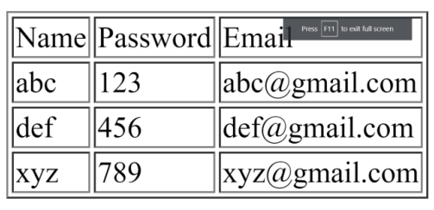

**Practical 21:**

**AIM: Write a PHP Script for login authentication. Design an html form which takes username and password from user and validate against stored username and password in file.**

**Code:**

**<html>**

**<head>**

**<title>PHP login system</title>**

**<link rel = "stylesheet" type = "text/css" href = "style.css">**

**</head>**

**<body>**

**<div id = "frm">**

**<h1>Login</h1>**

**<form name="f1" action = "authentication.php" onsubmit = "return validation()" method = "POST">**

**<p>**

**<label> UserName: </label>**

**<input type = "text" id ="user" name = "user" />**

**</p>**

**<p>**

**<label> Password: </label>**

**<input type = "password" id ="pass" name = "pass" />**

**</p>**

**<p>**

**<input type = "submit" id = "btn" value = "Login" />**

**</p>**

**</form>**

**</div>**

**<script>**

**function validation()**

**{**

**var id=document.f1.user.value;**

**var ps=document.f1.pass.value;**

**if(id.length=="" && ps.length=="") {**

**alert("User Name and Password fields are empty");**

**return false;**

**}**

**else**

**{**

**if(id.length=="") {**

**alert("User Name is empty");**

**return false;**

**}**

**if (ps.length=="") {**

**alert("Password field is empty");**

**return false;**

**}**

**}**

**}**

**</script>**

**</body>**

**</html>**

**Output:**

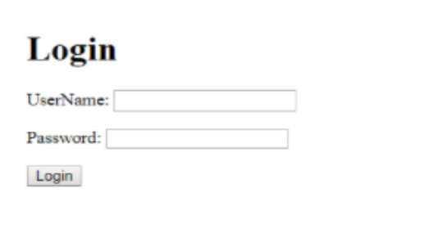

**Practical 22:**

**AIM: Write PHP Script for storing and retrieving user information from MySql table. 1. Design A HTML page which takes Name, Address, Email and Mobile No. From user (register.php) 2. Store this data in Mysql database / text file. 3. Next page display all user in html table using PHP ( display.php ).**

**Code:**

**connection.php:**

**<?php**

**$host="127.0.0.1:3308";**

**$user="root";**

**$pass="";**

**$db="test";**

**$con=mysqli_connect($host,$user,$pass,$db);**

**if ( mysqli_connect_errno() ) {**

**// If there is an error with the connection, stop the script and display the error.**

**exit('Failed to connect to MySQL: ' . mysqli_connect_error());**

**}**

**?>**

**modified.php:**

**<!DOCTYPE html>**

**<html>**

**<head>**

**<title>Insert Page page</title>**

**</head>**

**<body>**

**<center>**

**<?php**

**include "connection.php";**

**// Taking all 5 values from the form data(input)**

**$Name = $_REQUEST['Name'];**

**$Email = $_REQUEST['Email'];**

**$ContactNo = $_REQUEST['ContactNo'];**

**$Address = $_REQUEST['Address'];**

**// Performing insert query execution**

**$sql = "INSERT INTO itwpr22 VALUES ('$Name',**

**'$Email','$ContactNo','$Address')";**

**if(mysqli_query($con, $sql)){**

**echo "<h3>data stored in a database successfully."**

**. " Please browse your localhost php my admin"**

**. " to view the updated data</h3>";**

**echo nl2br("\n$Name\n $Email\n "**

**. "$ContactNo\n $Address");**

**} else{**

**echo "ERROR: Hush! Sorry $sql. "**

**. mysqli_error($conn);**

**}**

**// Close connection**

**mysqli_close($con);**

**?>**

**</center>**

**</body>**

**</html>**

**prac_22.php:**

**<!DOCTYPE html>**

**<html>**

**<head>**

**<title>Reg Form</title>**

**<style type="text/css">**

**.headercont{**

**font-family:Tahoma, Geneva, sans-serif;**

**font-size: 70px;**

**color: #7CFF01;**

**border-style: double;**

**}**

**input[type=text],textarea{**

**background-color: transparent;**

**width: 95%;**

**color:white;**

**border-color: transparent;**

**}**

**input[type=text]:hover{**

**background-color: blue;**

**border-color: transparent;**

**}**

**input[type=submit]{**

**width: 100%;**

**color: white;**

**background-color: transparent;**

**}**

**input[type=submit]:hover{**

**background-color: #B2E3FB;**

**color: black;**

**}**

**::placeholder{**

**color: white;**

**opacity: 50%;**

**}**

**.regform{**

**font-family: Tahoma, sans-serif;**

**font-size: 23px;**

**color:white/*F3F315 39FF14*/;**

**border-style: double;**

**border-radius: 3px;**

**text-align: center;**

**}**

**.regform:hover{**

**border: hidden;**

**}**

**.reghead{**

**font-family:Tahoma, Geneva, sans-serif;**

**font-size: 20px;**

**color: #0CF;**

**border-style: double;**

**color: #FFFF00;**

**text-align: center;**

**}**

**.footercont{**

**font-family:Tahoma, Geneva, sans-serif;**

**font-size: 30px;**

**color: #0CF;**

**border-style: double;**

**}**

**</style>**

**</head>**

**<body style="background-image: url(bg.jpg); background-size: cover; background-repeat:**

**no-repeat;">**

**<header>**

**<table border="0" width="100%">**

**<tr>**

**<td width="100%" align="center"**

**class="headercont">Registration Form</td>**

**</tr>**

**</table>**

**</header>**

**<article>**

**<form method="get" id="f1" action="modified.php">**

**<table border="0" width="30%" align="center">**

**<tr>**

**<td class="reghead" colspan="2">Registration**

**Form</td>**

**</tr>**

**<tr>**

**<td class="regform" width="27%">Name</td>**

**<td class="regform" width="73%"><input type="text"**

**placeholder="Enter your name" name="Name"></td>**

**</tr>**

**<tr>**

**<td class="regform" width="27%">Email</td>**

**<td class="regform" width="73%"><input type="text"**

**placeholder="ex:myname@example.com" required name="Email"></td>**

**</tr>**

**<tr>**

**<td class="regform" width="27%">Contact No</td>**

**<td class="regform" width="73%"><input type="text"**

**placeholder="1234567890" pattern="[0-9]{10}" name="ContactNo"**

**maxlength="10"></td>**

**</tr>**

**<tr>**

**<td class="regform" width="27%">Address</td>**

**<td class="regform" width="73%"> <textarea**

**rows="4" cols="50" name="Address" form="regform"> Enter your address**

**here...</textarea></td>**

**</tr>**

**</table>**

**<table border="0" align="center" width="30%">**

**<tr>**

**<td class="regform" width="50%"><input type="submit"**

**value="Cancel" formmethod="post" formtarget="blank"></td>**

**<td class="regform" width="50%"><input type="submit"**

**value="Register" formmethod="get" formtarget="_parent" formnovalidate></td>**

**</tr>**

**<tr></tr>**

**</table> </form> </article>**

**<footer>**

**<table border="0" width="100%">**

**<tr></tr>**

**<tr>**

**<td width="100%" align="center"**

**class="footercont">Copyright &copy; All Rights Reserved</td>**

**</tr>**

**</table>**

**</footer>**

**</body>**

**</html>**

**Output:**

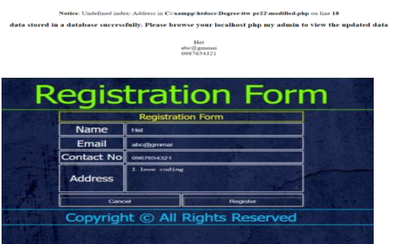

**Practical 23:**

**AIM: Create one blog website using wordpress, using different available plug-in (take free available theme) But, try to implement all the features of the blog website.**

**Output:**

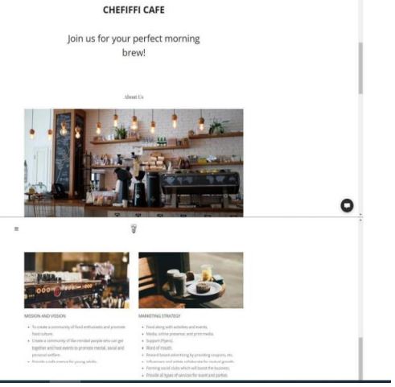

**Practical-24**

**AIM: Implement the basic website structure using Codeigniter Framework.**

**Code:**

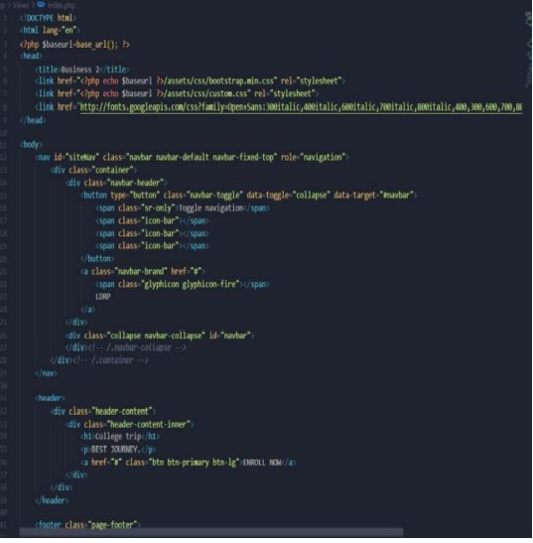



**Practical 25:**

**AIM: Using ajax fetch information from a database with AJAX.**

**Code:**

**Ajax.script.js:**

**$(document).on('click','#showData',function(e){**

**$.ajax({**

**type: "GET",**

**url: "backend-script.php",**

**dataType: "html",**

**success: function(data){**

**$("#table-container").html(data); }**

**}); });**

**Backend-script.js:**

**<?php**

**include("database.php");**

**$db=$conn;**

**// fetch query**

**function fetch_data(){**

**global $db;**

**$query="SELECT * from usertable ORDER BY id DESC";**

**$exec=mysqli_query($db, $query);**

**if(mysqli_num_rows($exec)>0){**

**$row= mysqli_fetch_all($exec, MYSQLI_ASSOC);**

**return $row;**

**}else{**

**return $row=[];**

**} }**

**$fetchData= fetch_data();**

**show_data($fetchData);**

**function show_data($fetchData){**

**echo '<table border="1">**

**<tr>**

**<th>S.N</th>**

**<th>Full Name</th>**

**<th>Email Address</th>**

**<th>City</th>**

**<th>Country</th>**

**<th>Edit</th>**

**<th>Delete</th>**

**</tr>';**

**if(count($fetchData)>0){**

**$sn=1;**

**foreach($fetchData as $data){**

**echo "<tr>**

**<td>".$sn."</td>**

**<td>".$data['fullName']."</td>**

**<td>".$data['emailAddress']."</td>**

**<td>".$data['city']."</td>**

**<td>".$data['country']."</td>**

**<td><a href='crud-form.php?edit=".$data['id']."'>Edit</a></td>**

**<td><a href='crud-form.php?delete=".$data['id']."'>Delete</a></td>**

**</tr>";**

**$sn++; }**

**}else{**

**echo "<tr>**

**<td colspan='7'>No Data Found</td>**

**</tr>";**

**}**

**echo "</table>";**

**}**

**?>**

**data-list.php:**

**<!DOCTYPE html>**

**<html>**

**<head>**

**<meta name="viewport" content="width=device-width, initial-scale=1">**

**</head>**

**<body>**

**<button id="showData">Show User Data</button>**

**<div id="table-container"></div>**

**<script src="https://ajax.googleapis.com/ajax/libs/jquery/3.4.1/jquery.min.js"></script>**

**<script type="text/javascript" src="ajax-script.js"></script>**

**</body>**

**</html>**

**database.php:**

**<?php**

**$hostname = "localhost";**

**$username = "root";**

**$password = "";**

**$databasename = "userdata";**

**$conn = mysqli_connect($hostname, $username, $password,$databasename);**

**// Check connection**

**if (!$conn) {**

**die("Unable to Connect database: " . mysqli_connect_error());**

**}**

**?>**

**Output:**

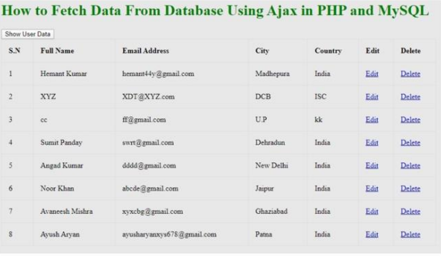

**Practical 26:**

**AIM: Install SciLab and get familiar with the general environment and console.**

**Output:**

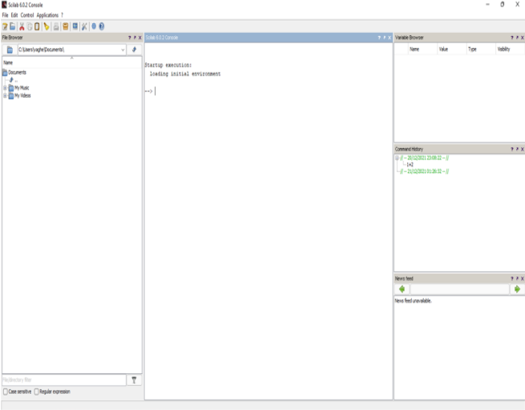

**Practical 27:**

**AIM:Get simple mathematical/numerical operations executed in SciLab.**

**Code:**

**Startup execution: loading initial environment**

**1) --> 1+2 ans= 3.**

**2) --> 2*3 ans =6.**

**3) --> 5%2**

**5%2**

**^~~^**

**Error: syntax error, unexpected identifier, expecting end of file**

**4) --> 2**5 ans =32.**

**5) --> 2^ 8 ans =256.**

**6) --> 90-1 ans = 78**

**Output:**

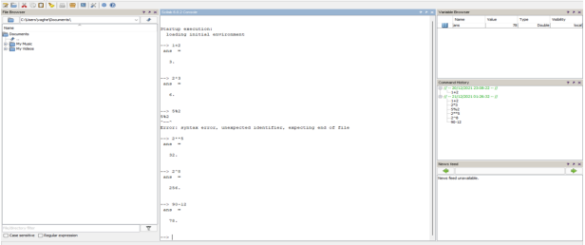

**Practical 28:**

**AIM: Plot curves/graphs using the graphics window.**

**Code:**

**function sinplot2(inital, final, N, v1, v2, v3)**

**x1=linspace(inital,final,N)**

**x2=linspace(inital,final,N)**

**x3=linspace(inital,final,N)**

**y=sin(2*%pi*v1*x1)**

**y1=sin(2*%pi*v2*x2)**

**y2=sin(2*%pi*v3*x3)**

**plot(x1,y,'O-r')**

**plot(x2,y1,'x-b')**

**plot(x3,y2,'*-g')**

**xlabel("x_axis(simple points"+string(N)+")")**

**ylabel("f(x)=sin")**

**title('sin plot for different frequencies')**

**endfunction**

**consol code:-**

**--> sinplot2(0,1,200,1,2,3)**

**Output:**